Internet of Things:
Internet of Things or IOT basically means connecting everyday devices such as smartwatches, fridges, microwaves, smart lights, etc., to the internet for sharing and collection of data.
Industrial Internet of Things:
IIoT are the devices which are mainly used in industries like manufacturing, energy, and transportation. One of the example can be that sensors on factory machines that alerts when a part might fail.
Key Difference Between Internet of Things and Industrial Internet of Things:
IoT are mainly used in homes, cities, consumer products, etc., and the main purpose of it is to make tasks comfortable and convenient. The failure impact are usually low like in a smart bulb and the security needed by the IoT devices are mainly of moderate level whereas,
IIoT devices are used in Factories, industries, heavy equipment, etc., and the main purpose of it is safety, efficiency and automation. The failure impact are usually high like for example stopping a production line and the security needed by IIoT devices is mainly very high.
3 Layers Industrial Internet of Things Architecture:
The three layer IIoT architecture:
- Edge Layer (Device Layer / Perception Layer)
- Cloud layer (Network / Data Processing Layer)
- SOC layer (Application layer / Visualisation & Control Layer)

- Edge Layer:
This is the layer where everything begins, it is like the eyes, ears and hands of an IIoT System. It is made up of physical devices like sensors, actuators, gateways, etc., that is directly connected to machines and tools on the factory floor. These devices constantly collect data from their surroundings like temperature, pressure, or speed and can even do some quick processing or simple analysis right there on the spot. This helps reduce the amount of data that needs to be sent over the network. Thanks to this setup, quick decisions and responses can happen locally, without always waiting for the cloud, which makes the system faster and more efficient.

- Cloud Layer:
This is the layer that acts like the brain of the IIoT system. This is where all the data collected from machines and sensors is sent, stored, and made sense of. It uses powerful cloud platforms like AWS IoT or Azure IoT Hub to gather and organize huge amounts of data. Once the data is in, smart tools and analytics engines can dig through it to find patterns, train machine learning models, and even predict problems before they happen—like spotting signs of a machine that might break down soon. Since the cloud has tons of computing power, it’s perfect for handling big data and helping companies make smarter, faster decisions.
- SOC Layer:
The Dashboard Layer, also known as the Application or Visualization & Control Layer, is where all the smart insights from the IIoT system come together in a way that people can actually see and use. It includes things like dashboards and HMIs (Human-Machine Interfaces) that show real-time data, trends, alerts, and key performance indicators (KPIs) in a clear and easy-to-understand format. This helps operators, engineers, and managers make informed decisions quickly. It’s also where the SOC (Security Operations Center) comes in, keeping an eye out for cyber threats, unusual activity, or anything that could put the system at risk. Whether it’s sending alerts when something’s wrong, generating reports, or helping respond to incidents, this layer brings everything together to keep operations smooth, safe, and under control.

Flow of Data in these Layers:
Edge Layer devices collects raw data from industrial equipment. Then some preprocessing is done on edge gateways and micro controllers which includes filtering (removing noisy data ), basic analytics (Extract simple insights locally to make fast, low-level decisions). Then the processed data is transmitted to the cloud using wired or wireless network.
The cloud stores the data (Machine data) and then the data is then organised and combined. It combines the data from different sources to get a full picture. The cloud uses smart programs to predict failure, find patterns and suggest improvements. The cloud takes all the complex data from machines and processes it into simple, clear visuals like charts, alerts, and reports. These insights are then sent to dashboards where managers can easily monitor performance, spot trends, and make decisions, while at the same time, they're also forwarded to the Security Operations Center (SOC), which keeps a close watch for any cyber threats, unusual behavior, or system failures to ensure everything stays secure and running smoothly.
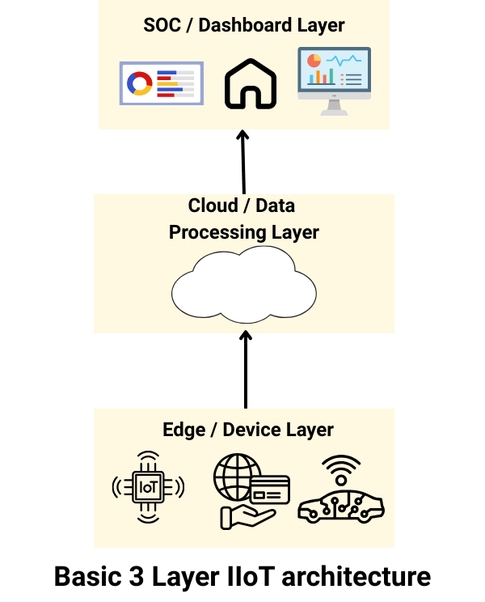

Application of Industrial Internet of Things:
IoMT Architecture Layers (Healthcare Use-Case):
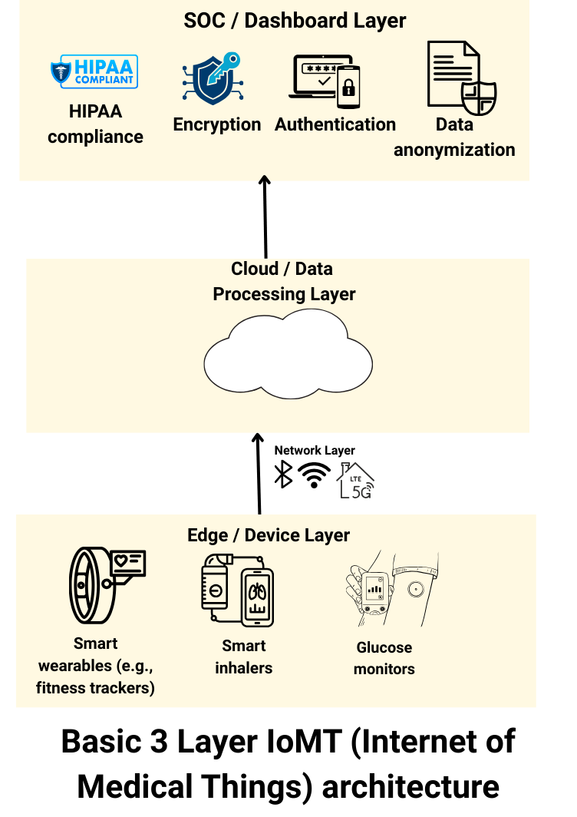

- Edge Layer:
Real-time Data Collection: Continuously gathers physiological data (e.g., heart rate, blood glucose, oxygen saturation) from patients.
On-Device Processing: Some devices process data locally using embedded microcontrollers or AI chips to detect simple anomalies or trends.
Noise Filtering & Preprocessing: Reduces raw sensor noise before transmission (e.g., smoothing ECG signals).
Battery/Power Management: Optimizes power usage for long-term monitoring.
Local Alerts: Some devices can give instant alerts (vibration/beep) for thresholds (e.g., high glucose level).
- Cloud Layer:
Secure Data Storage: Encrypts and stores vast amounts of structured and unstructured patient data (e.g., time-series, images, audio).
Advanced Analytics: Applies AI/ML algorithms to detect patterns, anomalies, or early signs of disease (e.g., arrhythmia prediction from ECG).
Data Aggregation: Combines data from various sources (wearables, apps, EHRs) for a holistic view.
Integration with Hospital Systems (EHRs): Ensures seamless sharing of cloud-processed data with medical staff.
Remote Monitoring Dashboard: Generates real-time health reports and flags urgent cases for doctors.

- Soc / Dashboard layer:
Data Encryption (At Rest & In Transit): Prevents data leaks during storage or transmission using protocols like TLS (for transport) and AES (for stored data).
Authentication & Access Control: Ensures only authorized users (e.g., doctors, caregivers) can access sensitive patient data.
HIPAA & Regulatory Compliance: Ensures the entire data lifecycle meets healthcare privacy regulations.
Data Anonymization/De-identification: Removes personally identifiable information for research while preserving analytic value.
Security Monitoring & Auditing: Logs and tracks access attempts or anomalies for breach detection.
Firmware/Software Updates: Ensures devices and systems are up-to-date with the latest security patches.

